MENG 4010 – INDUSTRIAL NETWORKING
Lab 01 Report – Configuring the IP Address of a ControlLogix 1756-L81E PLC and a Siemens S7-1200 G2 PLC

Item | Details
Student | Michael McCorkell (N01500049)
Course | MENG 4010 – Industrial Networking
Lab Date | September 10, 2026
Devices | Allen-Bradley ControlLogix 1756-L81E; Siemens SIMATIC S7-1200 G2
Software / tools | RSLinx Classic, Studio 5000 Logix Designer, FactoryTalk Linx, Rockwell BOOTP/DHCP EtherNet/IP Commissioning Tool, Siemens TIA Portal, Windows Command Prompt (ping, ipconfig, arp)

Instructor’s Confirmation
The course instructor’s signature below verifies completion of the lab demonstration.
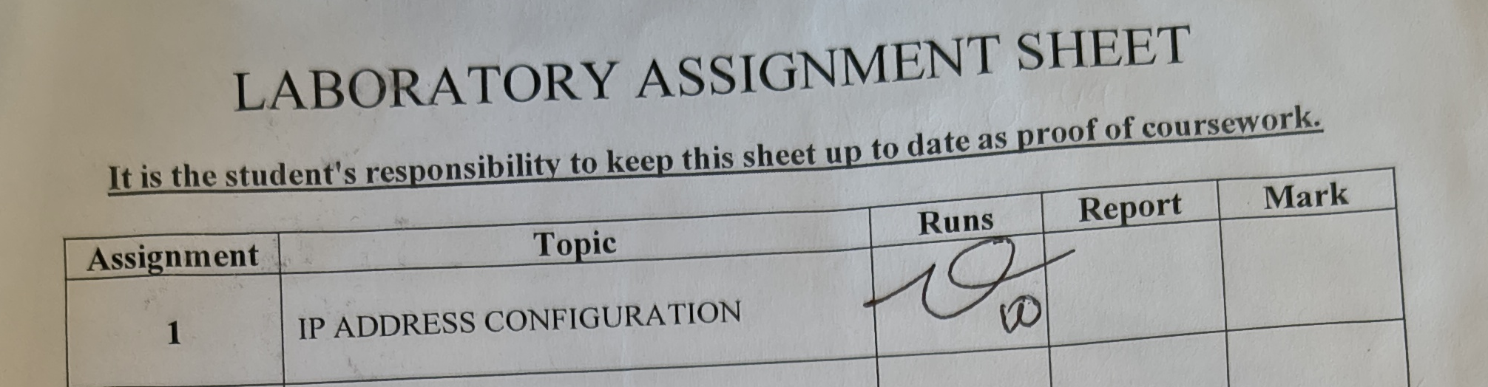

1. Assignment Summary

1.1 Objectives
The purpose of this lab was to gain hands-on experience assigning and changing the IP address of industrial controllers using the tools commonly found on an industrial network. The specific objectives were to:
- Configure PLC network settings using a USB connection, a BOOTP/DHCP server, and Ethernet-based software tools.
- Validate every IP change with system tools (ping, ipconfig, arp, RSLinx/FactoryTalk Linx browsing) and document the address before and after the change.
- Identify the advantages and limitations of each configuration method.

1.2 Work Completed
Five methods were carried out. Four were performed on the ControlLogix 1756-L81E (RSLinx, Studio 5000, BOOTP/DHCP, and USB) and one on the Siemens S7-1200 G2 (TIA Portal). All addresses were on the 10.116.254.0/24 subnet (mask 255.255.255.0, gateway 10.116.254.1). Table 1 summarises the before and after address for each method; the supporting screenshots are in Section 2.
Table 1 – IP address before and after each method
Method | Device | IP before | IP after | Verification
RSLinx | ControlLogix 1756-L81E | 10.116.254.212 | 10.116.254.250 | Ping replies from PLC; visible in RSWho at .250
Studio 5000 | ControlLogix 1756-L81E | 10.116.254.250 | 10.116.254.251 | Ping replies from PLC; visible in RSWho / Who Active at .251
BOOTP/DHCP | ControlLogix 1756-L81E | 10.116.254.7 | 10.116.254.250 (relation created) | ARP entry for .250 and “Enable DHCP successful”; ping to .250
USB (RSLinx) | ControlLogix 1756-L81E | No valid IP (0.0.0.0 shown over USB) | 10.116.254.212 | Ping replies from PLC at .212
TIA Portal | Siemens S7-1200 G2 | 10.116.254.212 | 10.116.254.254 | Ping replies from PLC at .254

1.3 Conclusions
Every method was able to give a controller a valid address on the lab subnet, and the ping test clearly showed the change: before each change the new address returned “Destination host unreachable” from the network gateway, and after the change it returned direct replies from the PLC. The lab showed that the right method depends on the situation. USB and BOOTP work on a controller with no usable IP (for example a brand-new unit), whereas RSLinx and Studio 5000 are quick but need the PLC to be reachable on the network already. On the Siemens side, the address is assigned from TIA Portal. The main lesson is that an IP change should always be confirmed at both the network layer (ping) and the application layer (a Who Active / RSWho browse), because ping alone does not prove that the controller is communicating.

2. Program Documentation
Screenshots are grouped by method. The “before” and “after” IP addresses are stated in each subsection heading and in the figure captions.

2.1 RSLinx – 10.116.254.212 → 10.116.254.250
The PLC was found at 10.116.254.212, which matches the label on the trainer (Figure 3). The new address, .250, was confirmed to be free by pinging it first (Figure 2); the replies came from the gateway, not from a device. In RSLinx, the Port Configuration tab of the 1756-L81E was changed from .212 to .250 with the static setting, mask 255.255.255.0 and gateway 10.116.254.1.
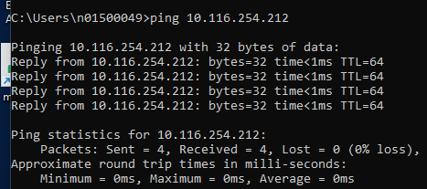  Figure 1 – Ping to 10.116.254.212 (BEFORE): replies received from the PLC | 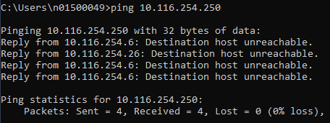  Figure 2 – Ping to 10.116.254.250 (BEFORE): destination host unreachable, address free
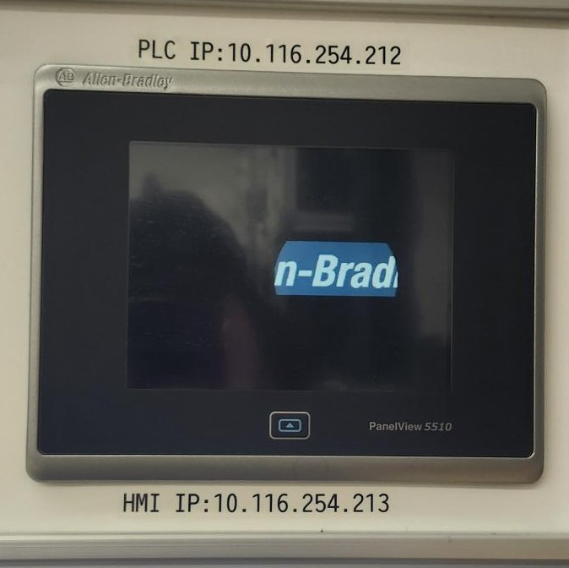  Figure 3 – Trainer label: PLC IP 10.116.254.212, HMI IP 10.116.254.213 | 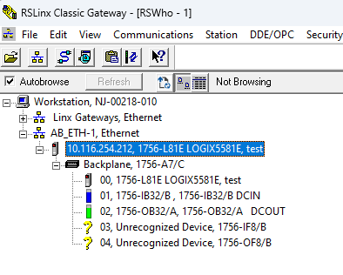  Figure 4 – RSLinx RSWho: PLC at 10.116.254.212 (BEFORE)
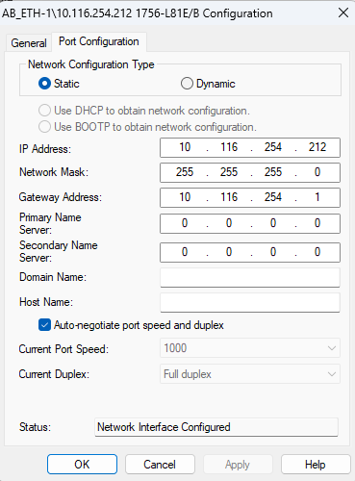  Figure 5 – Port Configuration (BEFORE): IP 10.116.254.212 | 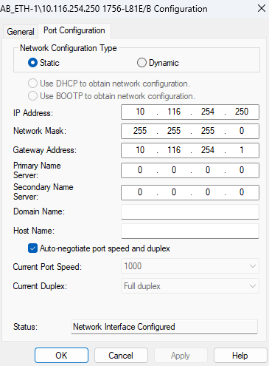  Figure 6 – Port Configuration (AFTER): IP 10.116.254.250
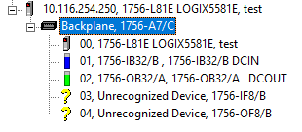  Figure 7 – RSWho (AFTER): PLC now at 10.116.254.250 | 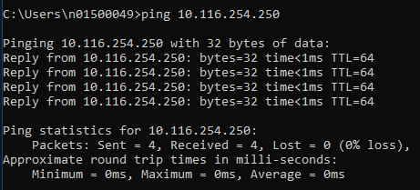  Figure 8 – Ping to 10.116.254.250 (AFTER): direct replies from the PLC

2.2 Studio 5000 – 10.116.254.250 → 10.116.254.251
With the PLC online at 10.116.254.250 (Logix Designer path shown in Figure 10), the IP settings were changed from the Ethernet port of the controller’s I/O configuration. As before, .251 returned “destination host unreachable” before the change and direct replies afterward, while the old address .250 stopped answering.
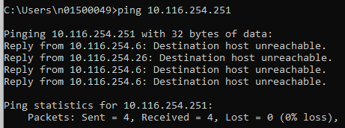  Figure 9 – Ping to 10.116.254.251 (BEFORE): unreachable | 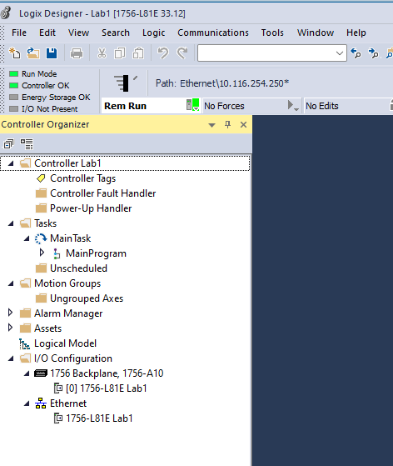  Figure 10 – Logix Designer online, path Ethernet\10.116.254.250 (BEFORE)
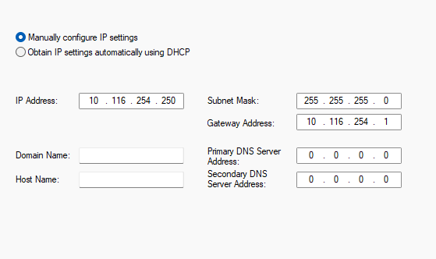
Figure 11 – Ethernet port settings: manually configured IP, mask 255.255.255.0, gateway 10.116.254.1 (BEFORE edit shows .250)
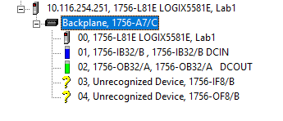  Figure 12 – RSWho (AFTER): PLC listed at 10.116.254.251 | 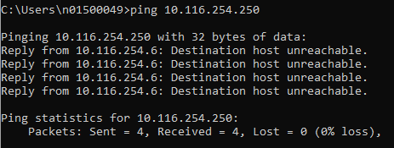  Figure 13 – Ping to old address 10.116.254.250 (AFTER): now unreachable
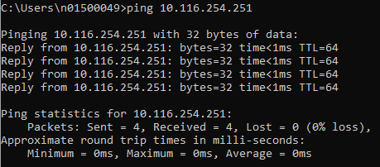  Figure 14 – Ping to 10.116.254.251 (AFTER): direct replies from the PLC | 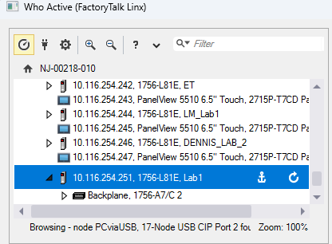  Figure 15 – FactoryTalk Linx Who Active: PLC at 10.116.254.251
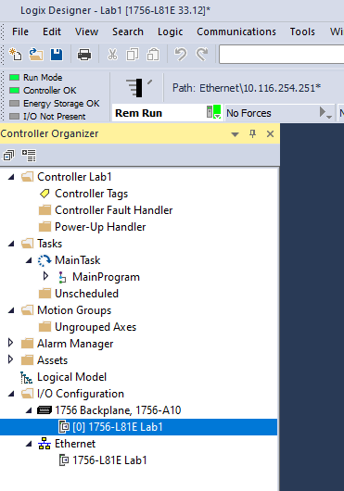
Figure 16 – Logix Designer online, path Ethernet\10.116.254.251 (AFTER)

2.3 BOOTP/DHCP – IP assigned 10.116.254.250
BOOTP requests are sent as broadcasts, so the Windows firewall was checked first (it was off for the domain network, Figure 18) and the workstation was given a static address of 10.116.254.250 (Figures 19–20). In the Rockwell BOOTP/DHCP tool, the controller’s request appeared in the discovery history and a relation was created that maps its MAC address to 10.116.254.250. The Enable BOOTP/DHCP command reported success and the ARP table then showed a dynamic entry for 10.116.254.250.
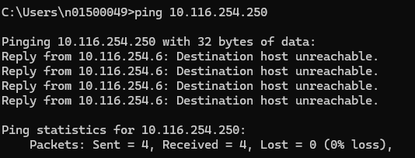
Figure 17 – Ping to 10.116.254.250 (BEFORE workstation was set): unreachable
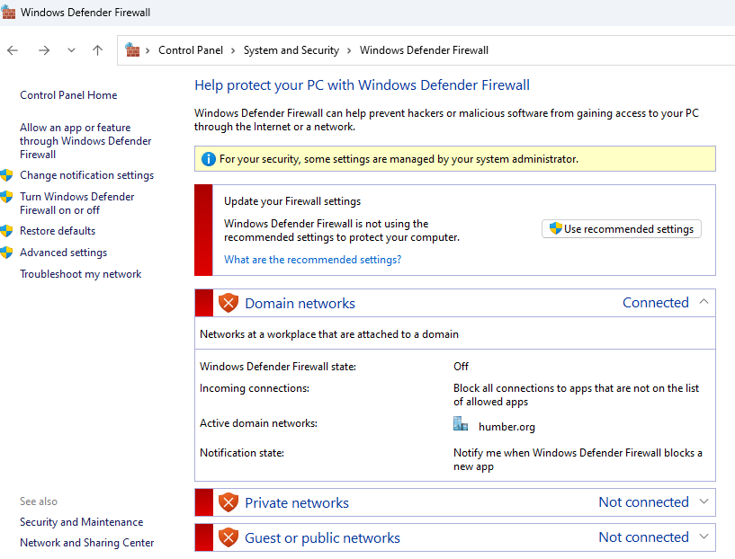
Figure 18 – Windows Defender Firewall status (domain network: firewall off)
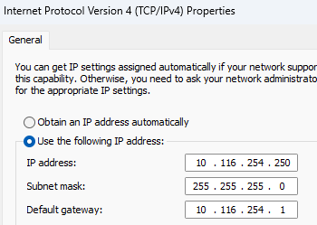  Figure 19 – Workstation TCP/IPv4 settings: 10.116.254.250 / 255.255.255.0 / 10.116.254.1 | 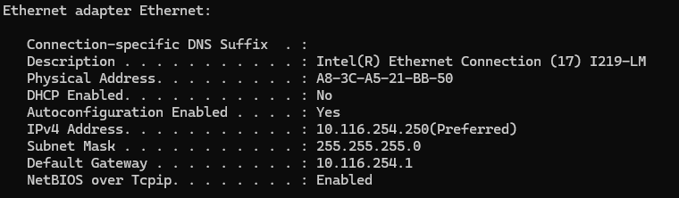  Figure 20 – ipconfig output confirming the workstation address
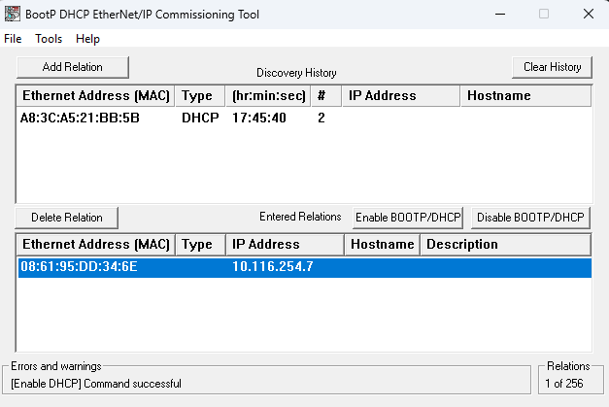
Figure 21 – BOOTP/DHCP tool: request in discovery history, relation created for 10.116.254.7, “Enable DHCP command successful”
Figure 22 – ARP table: 10.116.254.7 mapped to MAC 08-61-95-dd-34-6e (dynamic)

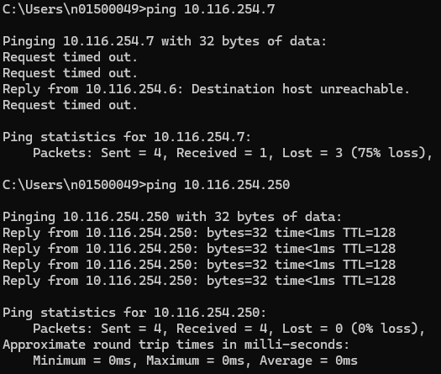
Figure 23 – Ping to 10.116.254.7 (3 of 4 requests timed out) and ping to workstation address 10.116.254.250 (replies)

2.4 USB – 0.0.0.0→ 10.116.254.212
The controller was not reachable at .212 over Ethernet (Figure 24). It was then browsed over the USB port in RSLinx, where the Ethernet port appeared with 0.0.0.0. Its port configuration was set to static 10.116.254.212, mask 255.255.255.0, gateway 10.116.254.1, DNS servers 10.114.255.252 / 10.114.0.252, and domain humber.org. Ping replies from the PLC confirmed the change.
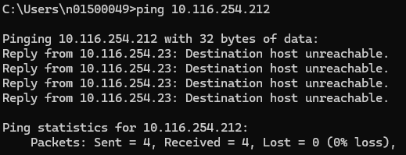  Figure 24 – Ping to 10.116.254.212 (BEFORE): unreachable | 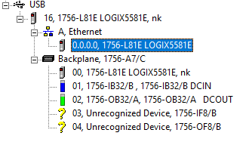  Figure 25 – RSLinx over USB: Ethernet port shown as 0.0.0.0 (BEFORE)
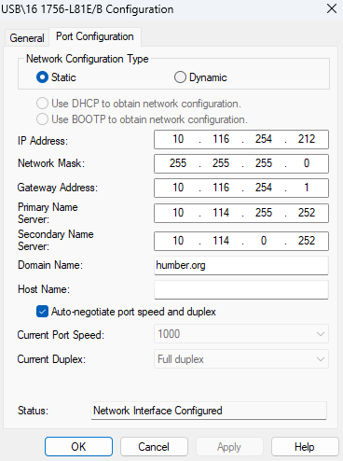  Figure 26 – USB Port Configuration (AFTER): static IP 10.116.254.212 | 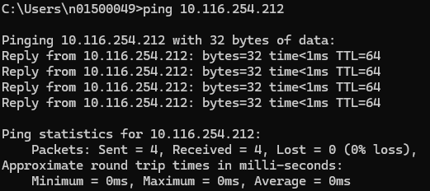  Figure 27 – Ping to 10.116.254.212 (AFTER): direct replies from the PLC

2.5 Siemens S7-1200 G2 (TIA Portal) – IP assigned 10.116.254.254
The address was assigned from TIA Portal with the Assign IP address dialog: subnet mask 255.255.255.0 and the router option left unchecked. Before the assignment, .254 returned “destination host unreachable”; afterward, the PLC answered directly.
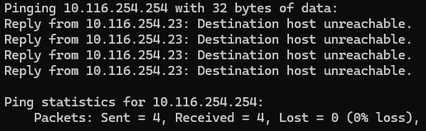
Figure 28 – Ping to 10.116.254.254 (BEFORE): unreachable
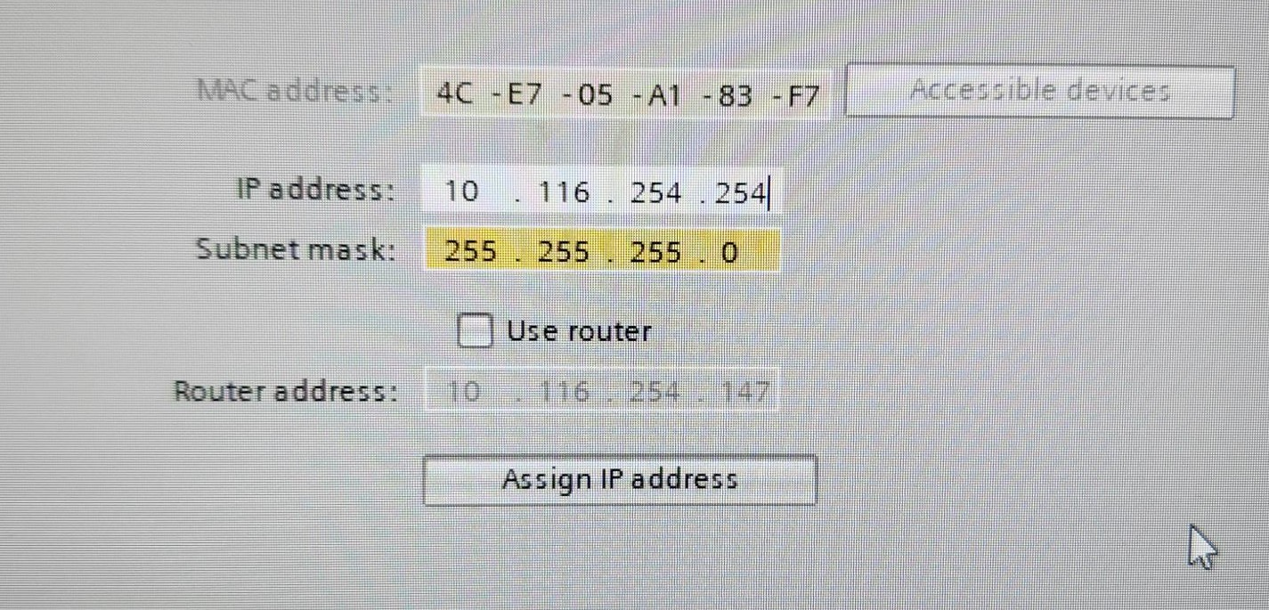
Figure 29 – TIA Portal Assign IP address dialog (subnet mask 255.255.255.0, use router unchecked)
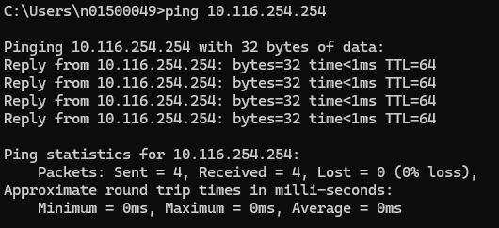
Figure 30 – Ping to 10.116.254.254 (AFTER): direct replies from the PLC

3. Results and Reflection

3.1 Link to theory
All devices were on one IPv4 network, 10.116.254.0/24. Two hosts can talk directly only when they share the same network portion of the address, which the mask 255.255.255.0 defines; anything else must go through the gateway 10.116.254.1. This explains the “Destination host unreachable” replies seen before each change: with nobody holding that address, the request was answered by a network device (10.116.254.6 or .26) rather than by the target. Ping uses ICMP echo, so a reply from the correct address with TTL 64 shows the PLC’s network stack is answering, while a reply with TTL 128 (Figure 23, last ping) came from the Windows workstation itself.
BOOTP (and DHCP, which extends it) assigns an address to a device based on its MAC address. A ControlLogix controller straight from the factory has BOOTP enabled, so it asks the network for an address; once a static address is set, BOOTP/DHCP should be disabled so that the PLC keeps it. Every address on an industrial network must be unique, because a duplicate address would disrupt communication with a running controller.

3.2 Comparison of methods
Method | Advantages | Limitations
USB (serial-type) | Works on a controller with no IP; no network setup needed; useful for recovery. | Needs a physical cable at the controller; slower to set up.
BOOTP/DHCP | Can commission many new devices from a central tool; works on factory-default controllers. | Needs a broadcast path (firewall must allow it); works only for controllers with BOOTP enabled; BOOTP/DHCP must be disabled afterwards to keep the address.
RSLinx | Quick, done from the workstation once the PLC is visible in RSWho. | PLC must already be reachable; needs the correct driver configured.
Studio 5000 | Changes the address from within the project and controller properties. | Requires the project/online path; the connection is lost when the IP changes and the path must be updated.
TIA Portal (Siemens) | Direct address assignment for S7-1200 G2 with the mask and router options in one dialog. | Requires Siemens software and a compatible network adapter selection.

3.3 Errors and limitations
- Ping statistics can be misleading. Windows counted the “Destination host unreachable” replies as received packets (“0% loss”), so a ping summary alone does not show that the PLC answered. The reply’s source address must be checked.
- BOOTP result not fully confirmed. The relation for 10.116.254.7 was accepted and appears in the ARP table, but three of the four pings to .7 timed out (Figure 23). The address was therefore assigned in the tool, but a complete ping/RSWho confirmation was not captured. Possible causes include the controller not yet having applied the address, a firewall setting or the workstation address being on a different path.
- Unrecognised modules. RSWho shows two modules (1756-IF8/B and 1756-OF8/B) as unrecognised devices, most likely because their EDS files were not installed. This did not affect the IP change.
- Reachability is not communication. Ping proves only network-layer reachability, not that the PLC is running or accepting connections; the Who Active / RSWho browse gave the extra confirmation.

3.4 Possible improvements
- Record each device’s MAC address and planned IP in a table before starting, so the “before” and “after” values and the BOOTP relation can be checked against it.
- Verify the address in two ways after every change (ping with the correct reply source, plus a Who Active / RSWho browse) and capture both.
- After BOOTP assignment, use the Disable BOOTP/DHCP command (or set a static address) so that the controller does not lose its address on a power cycle.
- Reserve a documented address range for controllers and check that each new address is unused with a ping before assigning it, as was done in this lab, to avoid duplicate addresses.

Appendix – Application Photos
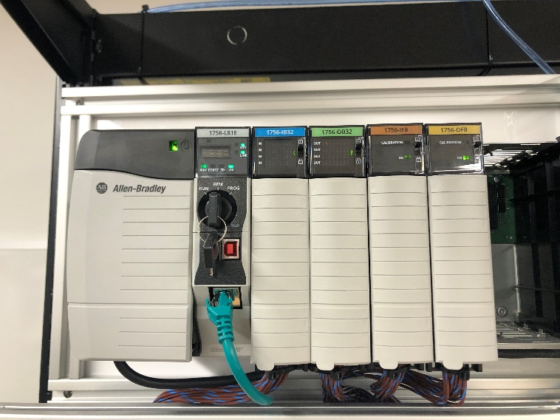
Figure 31 – ControlLogix chassis with 1756-L81E controller and I/O modules
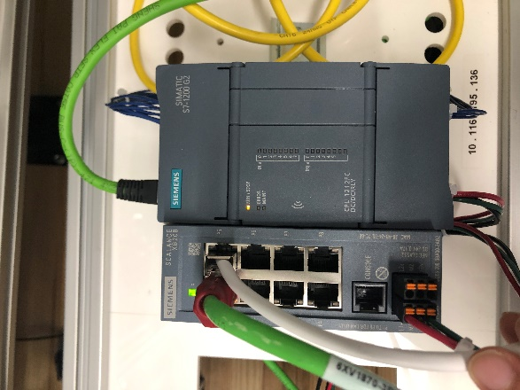
Figure 32 – Siemens SIMATIC S7-1200 G2 with Ethernet switch

